React Native Sports API Application

Id: K200219

Name: Muhammad Ferdeen Bakht

Introduction
The React Native Sports API application is a mobile app designed to provide users with fixtures and details for cricket and football matches. It leverages the Rapid API to fetch fixture data and displays it in an intuitive interface. The app includes features such as a splash screen, signup, login and separate tabs for home, cricket and football fixtures.
Features
- Splash Screen:
Upon launching the app, users are greeted with a splash screen featuring an icon representing the application.



- Signup Page:
Users can create new accounts by filling out the required information on the signup page. This ensures personalized experiences and access to additional features.



- Login Page:
Existing users can log in to their accounts securely via the login page. Authentication mechanisms protect user data and ensure privacy.

- Home Tab:
The home tab provides users with a welcoming interface, offering easy navigation to other sections of the app. It serves as the central hub for accessing various features and information.
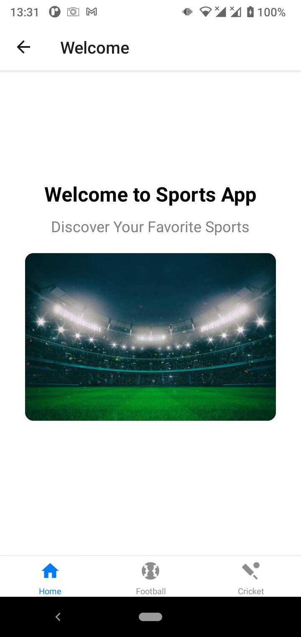

- Cricket Tab:
This tab utilizes the Rapid API to fetch cricket fixtures from a reliable data source. Users can browse through upcoming matches and view essential details such as teams, date, time, and venue.
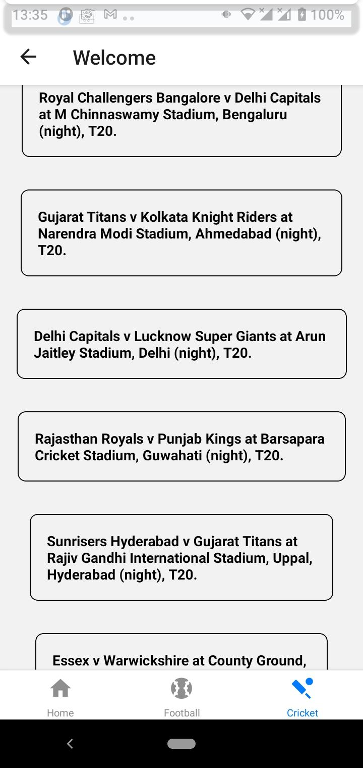

- Cricket Fixture Details:
Clicking on a specific cricket fixture expands to display comprehensive details, including team lineups, match statistics, and any additional information relevant to the match.

- Football Tab:
Similar to the cricket tab, the football tab fetches fixture data from the Rapid API. Users can explore scheduled football matches, review match details, and plan their viewing accordingly.
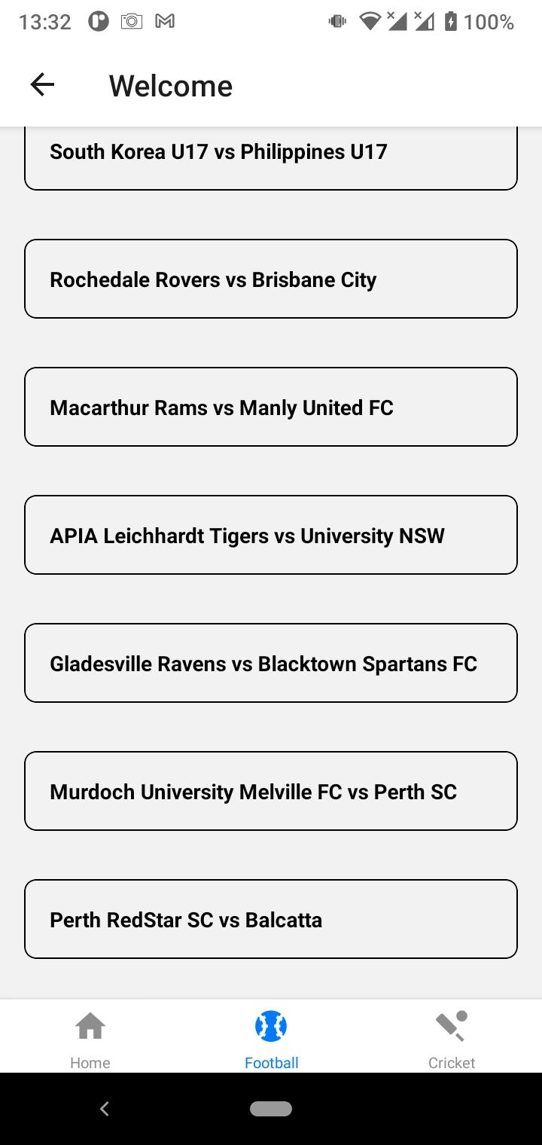

- Football Fixture Details:
Upon selecting a football fixture, users can access detailed information similar to the cricket fixtures. This includes team compositions, match predictions, and any noteworthy updates related to the match.
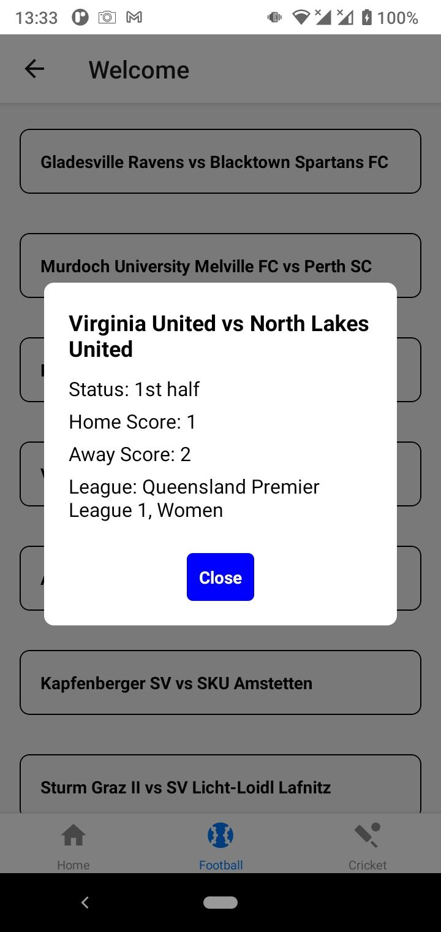

Technologies Used
- React Native: The framework for building cross-platform mobile applications.
- Rapid API: Integration with Rapid API facilitates seamless retrieval of fixture data for cricket and football matches.
- JavaScript: Programming languages used for implementing application logic and user interface components.
Conclusion
The React Native Sports API application offers an engaging platform for sports enthusiasts to stay updated with upcoming cricket and football fixtures. Through integration with Rapid API, users can access reliable and timely information about matches, enhancing their overall sports viewing experience. With its intuitive interface and essential features such as signup, login, and fixture details, the app aims to cater to the needs of users seeking convenient access to sports-related content on their mobile devices.

